Dear <Company> Repository Admins,
On <INSERT_DATE_HERE> we will be running a script that will enable Dependabot for approximately <NUMBER> repositories in the <ORGANIZATION> GitHub organization. You do not have to take any action at this time; this is a fully automated script. Changes will be applied and enforced at the Organization level, though a pull request will be generated. What this means is that repository Administrators will not be able to alter the majority of them; however, PRs MUST be approved for these changes to take place. Please send any questions to <CONTACT_LIST_HERE>. Once the script is run, you may notice some changes within your repositories, specifically in the Security tab and in the Code Security Analysis section of the repository settings tab:
Security
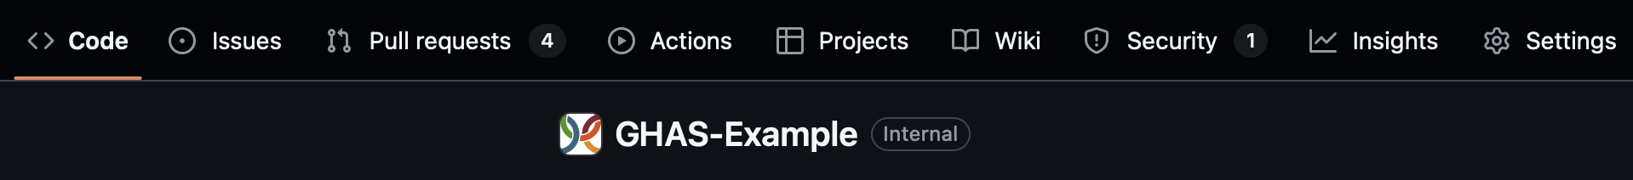
- Dependabot Alerts

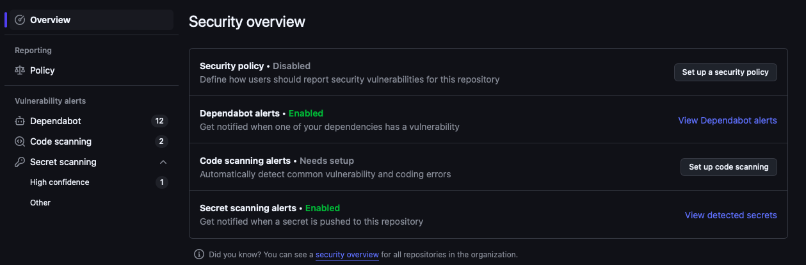

Code Security and Analysis

You can navigate to the Code Security and Analysis section of the settings tab by clicking Settings and then selecting “Code Security and Analysis”under Security in the left hand menu.
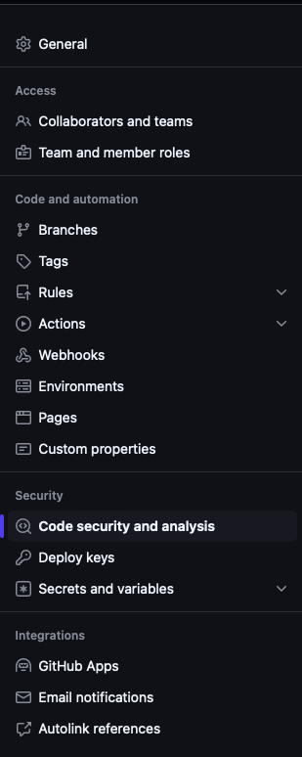

FAQs

- What exactly will be enabled?

The following GHAS-specific items will be enabled:
- Dependency graph to understand dependencies
- Dependabot alerts

The following GHAS-specific items will be disabled:
- Automatic dependency submission
- Dependabot security updates
- Grouped security updates

- Will I get alerts upon enablement?

Alerts will not be sent upon enablement, even if Dependency vulnerabilities are found. However, they will be sent for each subsequent finding.

- Will I be able to make changes as an administrator?

Most changes will be enforced at the Organization level, meaning you will not be able to make changes.

When the changes are complete, you will receive a follow-up email.

Thank you,

The Platform Architecture Team

